# 2025 Organics Management Grant

Administered by the Dane County Department of Waste & Renewables, the Organics Management Grant seeks to provide funding for community projects that help reduce the quantity of organic materials (i.e., food scraps, yard/ garden waste) being sent to landfills.

Organics, such as food scraps, comprise about one-third of the materials being sent to the Dane County landfill. The Environmental Protection Agency (EPA) offers the following recovery hierarchy to promote the productive use of excess food and food residuals:

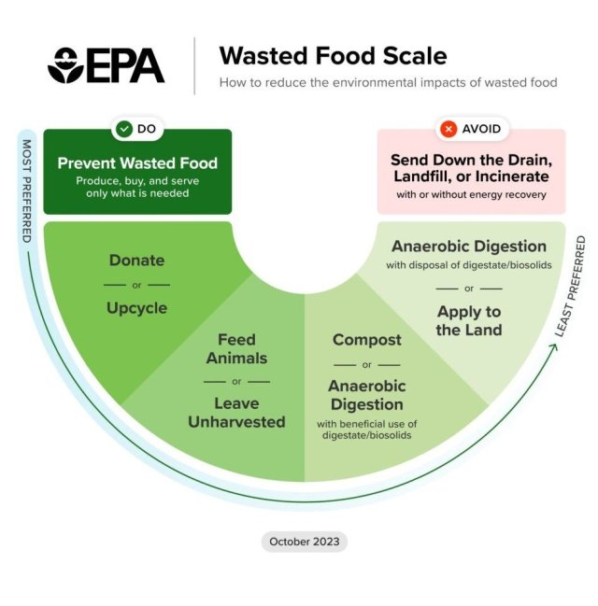

*Figure 1. Image courtesy of* [*EPA.*](https://www.epa.gov/sustainable-management-food/wasted-food-scale)

Dane County Waste & Renewables strives to support environmentally sound and sustainable waste management and renewable energy solutions that are in line with the EPA’s hierarchy through its innovative programs, partnerships, and grant programs.

## Eligibility and Award Details

### Who Is Eligible for Funding?

All Dane County area businesses, institutions, municipalities, Native American tribal governments and organizations, community groups, and nonprofit organizations are eligible.

### Eligible Projects & Available Funding

The Organics Management Grant is intended to help fund projects that reduce or eliminate the volume of organic materials, such as food scraps and yard waste, disposed of at the landfill. Projects that prevent wasted food, recover and donate excess food, upcycle or provide creative reuse for organic resources, or otherwise recycle organic materials (i.e., using compost, biochar, or digester processes) will be considered under this grant.

Examples of activities that would be eligible for funds include, but are not limited to:

* The purchase of supplies for on-site collection of food scraps, yard waste, and garden debris for organics recycling. The system must be available for use by all applicant community members or employees.
* Staff payroll hours put towards the establishment an on-site compost or collection system for a community, institutional facility or business.
* Consulting support for the development or expansion of a program to promote, educate, or otherwise enable efforts to reduce wasted food at its source, and/or provide reuse options.
* Supplies or payrolls for the development or expansion of a program to recover food for human consumption, or for recovery of food resources for use as animal feed.

Examples of project expenses that qualify include the purchase of equipment & supplies, and any printing and fabrication cost for projects. Grant funds allocated towards payroll expenses will be reimbursed at a maximum rate of $30/hr. Past project summaries are available for review on the Dane County Waste & Renewables [Website.](https://landfill.danecounty.gov/resources/compost)

A total of $10,000 is available in grant funding for FY25. Each applicant may receive up to $2,500 during this round of funding. More funding may be awarded on a case-by-case basis depending on requests for FY25. Applicants may submit more than one proposal, but only one proposal will be awarded per organization.

## Selection Criteria

See the rubric below for description of the application grading criteria.

|  |  |  |
| --- | --- | --- |
| **2025 Organics Management Grant Grading Rubric** | | |
|  | **Weight** | **Criteria** |
| Community Need & Impact | 20 | Narrative convincingly demonstrates need that would be bolstered by successful grant funding. Project impact is substantial and would not occur without grant funding. The grant reaches the maximum number of people reasonable for the grant ask. Project looks to successfully involve new and potentially underserved communities. Narrative should also demonstrate easy access for intended communities served. |
| Project Viability | 20 | The project goals are aligned with demonstrated need and achievable within the budget provided. The project team is equipped to facilitate the proposed project to completion. |
| Project Sustainability and Independence | 20 | Project will have high likelihood based on the narrative of continuing in the future and will not require additional County grant funds to maintain (future grants for expansion excluded from long-term viability). Project does not demonstrate reliance based on past funding. |
| Alignment of Budget | 20 | Budget size is reasonable for the project scope, items listed for procurement and services to be provided are achievable, and the purchasing needs are unlikely to veer from projections listed. Budget matches goals of the grant and narrated project. |
| Materials Diverted | 15 | Amount of food/ yard waste diverted from landfilling, quantities listed seem realistic within the scope of the project and would not be diverted without the proposed project or supporting grant funds. |
| Completion of Application | 5 | All application materials were completed and submitted on time. Word counts were respected. |
|  |  |  |
| **TOTAL** | **100** |  |

## Terms of Acceptance/Rejection Award of grant funding will be based upon how well the application meets the requirements and intent of the Organics Management Grant Program, as outlined in the Selection Criteria. Dane County Department of Waste & Renewables is the primary authority responsible for the approval of applications and reserves the right to reject any or all proposals. Expectations

## A Grant Agreement will be drafted and signed between Grantor (Dane County) and Grantee (Applicant/Awardee) outlining project scope of work, funding distribution timeline, and reporting requirements. Upon execution of the Grant Agreement, the Grantee agrees to provide data pertinent to the grant’s success. Final reports will be required documenting estimated waste diverted from the landfill, lessons learned and plans for future project sustainability. Failure to submit a final project report will make the Grantee organization ineligible from receiving future Organics Management Grant funding from the Grantor. If the Grantee has received prior funding from this grant and has yet to submit a final project report for a prior year, overdue final reports will be accepted as an attachment to their application for a current grant cycle for consideration on a case-by-case basis.

Grant awards will be distributed as a lump sum reimbursement following project completion. Expenses eligible for reimbursement must be incurred after the Grant Agreement is finalized. Project expenses must be incurred and listed within the invoice form, with all receipts or other proof of payment attached and submitted to Dane County Department of Waste & Renewables for payment. Partial up-front payments will be available on a case-by-case basis for organizations unable to pay their full project costs up front. In such a case, up to 80% of the award may be invoiced to the Grantor for payment at the outset of the project, given the submission of quotes or other cost estimates attached to the invoice form. The remaining 20% will be available once final receipts from the first invoice are provided. Invoice templates and final report forms will be provided to Grantees in the week following the award announcement following award announcement and written acceptance from Grantee. Dane County Waste & Renewables is available to provide technical expertise, training and assistance to awarded projects.

**Timeline**

* Open application period 3/1/25-4/4/25
* Application grading period 4/4/25-4/22/25
* Awards announced 4/22/25
* Grant Agreements completed by 6/1/25
* Grant Execution period 5/1/25-12/1/25
* Final reports due by 12/15/25

## Deadline Applications will receive priority consideration if received before April 4th, 2025. If funds remain after initial review, applications may be evaluated on a rolling basis.

## How To Apply Please complete the application on pages 6-10 of this document and submit as a PDF via email to Delaney Gobster at [Gobster.Delaney@danecounty.gov](mailto:Gobster.Delaney@danecounty.gov). Any attachments beyond the filled application template should be added to the end of the application and provided within the singular combined PDF. Letters of support and photo references for the project proposed will be accepted as attachments following the application form.

## For More Information Applicants can reach out to Delaney Gobster at [Gobster.Delaney@danecounty.gov](mailto:Gobster.Delaney@danecounty.gov) for additional clarification or questions about the Organics Management Grant application and grant funding process. Questions asked this way are subject to public disclosure and may be anonymously published on the department’s website, in order to provide consistent answers to all potential applications.

## Limitation of Liability Dane County assumes no responsibility or liability for costs incurred by parties in preparing or submitting applications for the Organics Management Grant. In addition, with the exception of municipal governments, applicants who become grant recipients must agree to indemnify Dane County and will have their grant conditioned upon providing proof of insurance.

# 2025 Organics Management Grant Application

#### Applicant Information

Name of Organization:

Organization Type:

Municipality

o

Tribal governments and organizations

o

o

Community group

Institution (i.e. business campus, university)

K-12 School

o

Residential building or housing  Non-profit organization

o

o

o

Business

Other:

Address:

Mailing Address (if differs from above):

Contact Person Name:

Contact Person Phone: Contact Person Email:

#### Organization Background- Describe the general function and makeup of your organization, with a focus on how the grant supported project fits into the broader operations of the organization. (250 words max):

#### Project Information- Describe project being funded including project objectives, established need, and project timelines. Include details on if this is a new project or an expansion of existing efforts and how the project intends to sustain itself into the future once funding concludes. (500 words max):

1. Expand upon your project’s team ability and/or qualifications to complete the proposed project **(100 words max):**

1. **Landfill Diversion-** Estimate the project’s organic waste diversion volume/tonnage. **(50 words max):**

1. **Previous Grant Funding-** (Previous Organics Management Grant awardees only) If you have received funding from a previous cycle of this grant, please indicate if you have submitted a final report for your previous project and describe how the project you are applying for this cycle expands on your previous project’s work. **(100 words max):**

1. **Community Need & Impact-** Detail the community your project intends to serve and the identified need for your project within that community. Explain what measures have or will take to reduce accessibility barriers to participating in your project/ program. **(250 words max):**

1. **Budget narrative-** Describe how the proposed budget that follows will be used to achieve your project’s objectives. **(500 words max):**

#### Grant Project Budget

Please itemize the materials and/or services you are requesting funds for using the grant project budget template below. You may add rows to the table for budgeted items as needed. If the total cost of an item exceeds the value you will request reimbursement for, list both the total and grant requested funds in the appropriate fields. Grant funds allocated towards payroll expenses will be reimbursed at a maximum rate of $30/hr.

|  |  |  |  |  |  |
| --- | --- | --- | --- | --- | --- |
| **Item** | **Description** | **Unit Cost** (if applicable) | **Quantity** (if applicable) | **Total Cost** | **Grant Funds Requested** |
|  |  |  |  |  |  |
|  |  |  |  |  |  |
|  |  |  |  |  |  |
|  |  |  |  |  |  |
|  |  |  |  |  |  |
|  |  |  |  |  |  |
|  |  |  |  |  |  |
|  |  |  |  |  |  |
| **Total Project Cost & Total Grant Funds Requested** | | | |  |  |

#### Applicant has read and understands the Terms of Acceptance for the Organics Management Grant.

Applicant Signature:

Date: